|  |  |  |  |  |  |  |
| --- | --- | --- | --- | --- | --- | --- |
| **name** | **name of village** | **residence** | **music** | **coffee** | **vocabulary** | **treatment order** |
| Bastian Carrasco | Edwardton | house 162 | no music | 250 | 20 |  |
| James McCarthy | Fairhaven | house 11 | no music | 250 | 18 |  |
| Daichi Gonzalez | Macondo | house 11 | no music | 250 | 20 |  |
| Ryan Steiner | Fairhaven | house 32 | no music | 250 | 18 |  |
| Daiki McCarthy | DeepBay | House 10 | no music | 250 | 17 |  |
| Antonella Carrasco | Rosica | house 3 | no music | 250 | 15 |  |
| Nathan Carrasco | Sunrise | house 22 | no music | 500 | 20 |  |
| Madison Summers | Roberts River | house 12 | no music | 500 | 17 |  |
| Katharina Steiner | Fairhaven | house 22 | no music | 500 | 17 |  |
| Kristina Lopez | Macondo | house 120 | no music | 500 | 18 |  |
| Ignacio Lopez | Alta | house 3 | no music | 500 | 14 |  |
| Naoto Durand | South Hope | house 3 | no music | 500 | 18 |  |
| Belen Durand | South Hope | house 10 | no music | 750 | 18 |  |
| Martina Durand | Riverside | house 2 | no music | 750 | 16 |  |
| ryan lopez | sunrise | house1 | no music | 750 | 17 |  |
| gen rodriguez | east bay | house1 | no music | 750 | 20 |  |
| Shota Lopez | Kuji | central | no music | 750 | 17 |  |
| michael Kennedy | Melville Cove | house 1 | no music | 750 | 16 |  |
| Bastian Carrasco | Edwardton | house 162 | heavy metal music | 250 | 15 | before drink |
| James McCarthy | Fairhaven | house 11 | heavy metal music | 250 | 15 | after drink |
| Daichi Gonzalez | Macondo | house 11 | heavy metal music | 250 | 18 | before drink |
| Ryan Steiner | Fairhaven | house 32 | heavy metal music | 250 | 15 | after drink |
| Antonella Carrasco | Rosica | house 3 | heavy metal music | 250 | 15 | before drink |
| Daiki McCarthy | DeepBay | House 10 | heavy metal music | 250 | 16 | after drink |
| Nathan Carrasco | Sunrise | house 22 | heavy metal music | 500 | 20 | before drink |
| Madison Summers | Roberts River | house 12 | heavy metal music | 500 | 16 | after drink |
| Katharina Steiner | Fairhaven | house 22 | heavy metal music | 500 | 18 | before drink |
| Kristina Lopez | Macondo | house 120 | heavy metal music | 500 | 17 | after drink |
| Ignacio Lopez | Alta | house 3 | heavy metal music | 500 | 14 | before drink |
| Naoto Durand | South Hope | house 3 | heavy metal music | 500 | 15 | after drink |
| Belen Durand | South Hope | house 10 | heavy metal music | 750 | 19 | before drink |
| Martina Durand | Riverside | house 2 | heavy metal music | 750 | 14 | after drink |
| ryan lopez | sunrise | house1 | heavy metal music | 750 | 18 | before drink |
| gen rodriguez | east bay | house1 | heavy metal music | 750 | 20 | after drink |
| Shota Lopez | Kuji | central | heavy metal music | 750 | 13 | before drink |
| michael Kennedy | Melville Cove | house 1 | heavy metal music | 750 | 14 | after drink |

**Statistics 101A Group members:**

**Final Project Report** Name: JiaLin Huang Email: vincenthjl@yahoo.com

Name: Wenting Li Email:mosquitowendy56@yahoo.com

Name: Junjie Qiu Email: [ismyucla@g.ucla.edu](mailto:ismyucla@g.ucla.edu)

1. According to the table above:

The data file is immediately readable into R, and it can be executed into summary and graphs without difficulty in R code.

In the data file above, you can clearly see there are totally 36 collected data under different conditions and treatments. However, we only have 18 persons consented to our study. The first row of the data table shows the factors about our data. There are names of our consented people, their addresses, two treatment factors and response factor. Music factor has two levels: no music and heavy metal music. Coffee factor contains three levels: 250ml, 500ml, 750ml.

Further, we also make a note on the treatment order when heavy metal music interacts into our coffee treatments. We assign one person to listen music before drinking coffee, and we assign another person to listen music after drinking coffee. The treatment order factor is just a note for reducing the error due to the learning effect, so we are not counting this factor into our experiment and R code test.

Our data should clearly shows every detail for supporting our experiment.

(b)

Nowadays, efficiency has become an important part of modern society. More companies and individuals gradually realize the importance of working efficiently, which can improve the both quantity and quality of work. People spend more time on researches to figure out effective factors for efficiency. A good memory is a basic element contributing to efficiency. So we will specify our research on the factors affecting memory. As we know, coffee is a necessary beginning for a day for majority of people in U.S, and also most people believe that music can improve working efficiency. In this way, our experiment is designed to test on the influence on memory test randomly caused by heavy metal music and different amounts of coffee in order to find the best combination for better memory to improve working efficiency. The design is interesting because this research is close to the real life of people, and it is also a concern in people’s life style that they are interested to figure out. From the analysis of our design, the conclusion is no music is better for memory under any levels of coffee, furthermore, the best combination is 250 ml coffee without music, which implies over-consumption of coffee will not help people’s memory. And also, heavy metal music is too loud for people to memorize more stuff and decrease the working efficiency.

(c)

The experiment is designed to test the effect by heavy metal music and different amounts of coffee. First, we randomly looked for a subject by going to a village and a house to obtain the consent of a random islander. For example, in order to choose a village randomly, we firstly wrote 38 village’s names on 38 cards. Then we shuffled these cards and took out one card from them to decide where we would go. At the same time, we used the same method to choose the residence (house’s #) and the islanders. Once an islander agrees to be tested, we assign each islander a number from 1 to 18, then we random shuffle them into three groups, and random assign three different levels of coffee to the three groups. After the shuffle and random assignment, the 18 islanders are equally divided into three groups for three different levels of coffee. Then the experiment is carried out in two parts. Part 1, we test the effect under music and coffee. First, we randomly assign the order of music and drink to them, so each subject randomly either listen to music first or drink coffee first. Then we offer them treatment factors -music and the assigned amount of coffee they need to drink by the order selected. After all, we will wait till 30 minutes and then offer them memory test of vocabulary, which let they try to memorize 20 words in one minutes and one minute later test how many words they can recall in 30 seconds. We create a table to record the number of words they still can memorize. Similarly to the part 1 process, for part 2, we offer the same 18 islanders only their assigned amounts of drink and do not offer them to listen to heavy metal music. After this, we will wait 30 minutes to offer them memory test of vocabulary again to see how many words they still can remember, and add the data to the table. After all data collection, we create a full table with observations’ names, locations, residence, order of music and coffee and treatments we offer them in details for future comparison.

Data are collected in this way to reduce the effect of nuisance factors. We need to randomize all assignments and orders to reduce effects caused by individual variances among each subject. So sample subjects need to be randomly chosen, and treatment factors should be randomly assigned to subjects in random order. Also, comparing the effect of music, we treat each subject as a blocking to test their memory test with and without music, which is more appropriate and accurate.

(d)

After the design of the experiment and data collection, we use R to analyze the data collected to run the two factorial anova test and plot the graphs for the output, residuals, qq plot and interaction. The residuals are averaged at zero, and the qq plot follows normal population, which proves that the model we used is correct and appropriate.

We anaylyze the data collected. According to the p-value, coffee and the interaction of coffee are not significant effective to the memory test, however, music has a slightly significant effect on the memoery test.

>output=aov(vocabulary~factor(coffee)+factor(music)+factor(coffee):factor(music),data=testform)

> summary(output)

Df Sum Sq Mean Sq F value Pr(>F)

factor(coffee) 2 0.22 0.111 0.027 0.9736

factor(music) 1 16.00 16.000 3.850 0.0591 .

factor(coffee):factor(music) 2 4.67 2.333 0.561 0.5762

Residuals 30 124.67 4.156

---

The Residuals are averaged at zero, which shows our experiment and dada collected are appropriate, and the two factorial model is correct.

plot(output)

-Residual with leverage

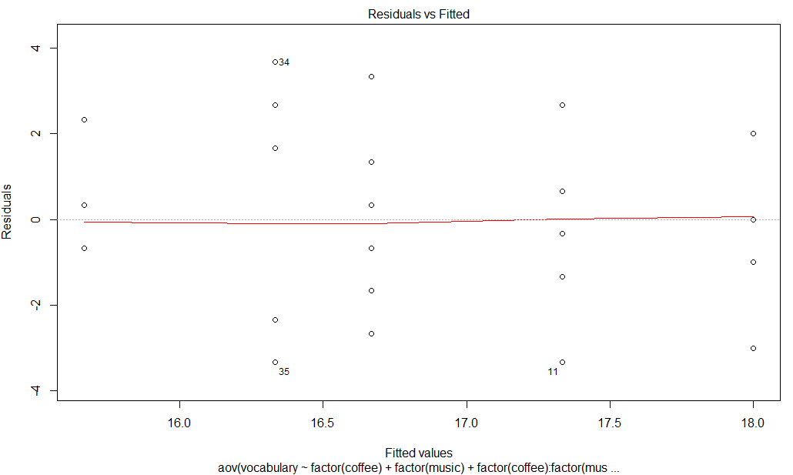

> qqnorm(output$residuals)

> qqline(output$residuals)

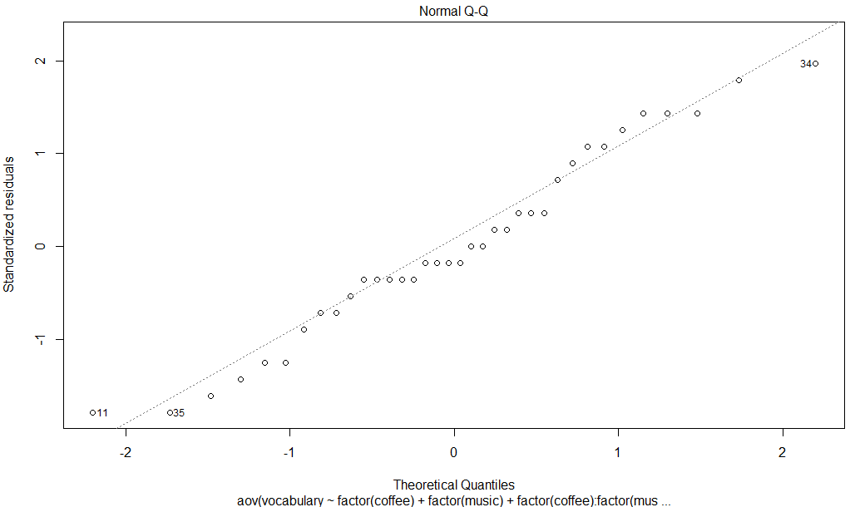

The qq plot follows normal population according to the above graph.

with(final.project.form,interaction.plot(drink,coffee,vocabulary))

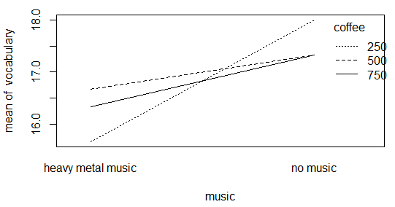

The interaction of coffee and music graphs shows that no music will help the memory test under all levels of coffee, and the best combination is 250 ml coffee without music.

We learnt the effects of the memory test by designing an experiment testing on heavy metal music and different amounts of coffee. We also learnt how to design a two factorial experiment, all factors we need to consider for design of experiment t, including controllable and uncontrollable, held-constant, and nuisance factors in real world situation. Furthermore, we learnt to randomize the assignment and add blocking to specify the test on the two treatment factors.

We do not need to clean the data, since we have double-checked our data that there is no unusual points or mistakes. And when we run our data into R, there is no error messages coming out. According to the graphs and data analysis, there is no extreme point, which shows our data collection is robust.

**(e)**

Conclusion:

According to the relative data above, we can conclude that:

1. The structure of our model is correct. By looking to the residual plot, variance of error looks constant. Also, it is shown qq-plot suggestive of Normal distribution. They are very important! Thus, we believe our predictions are reliable based on this model.
2. We slight agree heavy metal music and the interaction between coffee and heavy metal music have effect on this experiment. According to the summary of the anova test, we found that the p-values of coffee and the interaction of coffee and music are much larger than 0.05, which seems they are not significant. However, the music has a p-value close to 0.05, which shows a slightly relatively significant effect on the memory test. So we do not have enough evidence to conclude these factors don’t have effect. We just believe that we don’t have enough evident to reject the null hypothesis. The fact that these two factors are not significant may due to small sample size and the large effect size we used.
3. There are interactions between coffee and heavy metal music. According to the interaction plot, we found that all 3 levels of coffee interact with heavy metal music will have different effects on the mean of vocabulary. Firstly, we can tell that heavy metal music will have negative effect on the mean of vocabulary. The more metal music you listen, the less vocabulary you can remember. Also, without heavy metal music, drinking 250ml of coffee will have the highest mean of vocabulary than other 2 levels while drinking 500ml will have higher mean than drinking 750ml. In all, the best choice for you to have higher mean of vocabulary is drinking 250ml of coffee and do not listen to heavy metal music. With heavy metal music, drinking 500ml of coffee is the best choice to get higher mean of vocabulary.

All in all, the purpose of our study is to help people who often drinking coffee and listen heavy metal music at the same time to improve their efficiency on work. Believe it or not, many American love drinking coffee and listening heavy metal music. But they don’t know the interaction between these two factors will affect their memory. On our study, we believe that the result of memory vocabulary test can reflect how well of memory the people have, which is the an important element for working effeciency. Based on our analysis, we have some suggestions to American.

**If you want to have best efficiency on work or study, drinking a little bit amount of coffee like 250ml, without listening heavy metal music.**

**If you love drinking coffee and listening heavy metal music at the same time, we suggest you to drink less amount of coffee and listen less heavy metal music in order to have good memory.**

**If you are an enthusiast of heavy metal music and also like drinking coffee, we suggest you to drink medium amount of coffee like 500ml to have higher efficiency when you have listened the heavy metal music for a long time.**

(f) So far, after looking at on our experiment, we think it is appropriate to carry out, however, there still exist some weaknesses in our study. If we could do this again, we still can do some improvements.

Firstly, in order to increase the precision, increase sample size of our study if we have time. Right now, the effect size we use is 0.5, which is not bad but not perfect. Looking at the summary of the Anova test below, we found that the p-values of music and the interaction factor are a little bit larger than 0.05, which is not significant. However, is it means that these two factors don’t have effect? In our opinion, we just don’t have enough evidence to reject the null since the sample size is small. If we use the small effect size like 0.01, then our sample size will be larger. In this way, the factors may have lower p-values and lead to significant. Therefore, if we have time to do this again, we can use smaller effect size and more sample size to make our result more accurate.

Df Sum Sq Mean Sq F value Pr(>F)

factor(coffee) 2 0.22 0.111 0.027 0.9736

factor(music) 1 16.00 16.000 3.850 0.0591 .

factor(coffee):factor(music) 2 4.67 2.333 0.561 0.5762

Residuals 30 124.67 4.156

In addition, we can increase the time span between test with music and without music. According to our study, we have 36 observations and 18 subjects since we do 2 replications for each subject. Right now, firstly, we just gave subjects, then the memory vocabulary test. After 1 day, we gave subjects coffee and [Heavy Metal Music](http://island.maths.uq.edu.au/task.php?id=2drry&code=musicmetal) and the memory vocabulary test. Although the time span here we consider as nuisance factor, we still care about that whether 1 day is not long enough. We worried about that previous day’s treatment (just coffee) will still have effect on the response value of the subsequent test (given coffee and music). Therefore, if we do this experiment again, we may increase the time span like 2 days in order to make it more accurate.